**Documentation RESTful API**

API Documentation:

**GET /tasks**

Description: Retrieve a list of all tasks.

Request: **GET /tasks**

Response:

[ { "id": 1, "title": "Task 1", "description": "This is Task 1" }, { "id": 2, "title": "Task 2", "description": " This is Task 2" }]

**GET /tasks/:id**

Description: Retrieve a specific task by ID.

Request: **GET /tasks/1**

Response:

{ "id": 1, "title": "Task 1", "description": " This is Task 1" }

**POST /tasks**

Description: Create a new task.

Request:

{ "title": "New Task", "description": "Description of New Task" }

Response:

{ "id": 3, "title": "New Task", "description": "Description of New Task" }

**PUT /tasks/:id**

Description: Update an existing task by ID.

Request: **PUT /tasks/1**

{ "title": "Updated Task 1", "description": "Updated description of Task 1" }

Response:

{ "id": 1, "title": "Updated Task 1", "description": "Updated description of Task 1" }

**DELETE /tasks/:id**

Description: Delete a task by ID.

Request: **DELETE /tasks/1**

Response: Status code 204 (No Content)

**Output**

**Output from Postman**

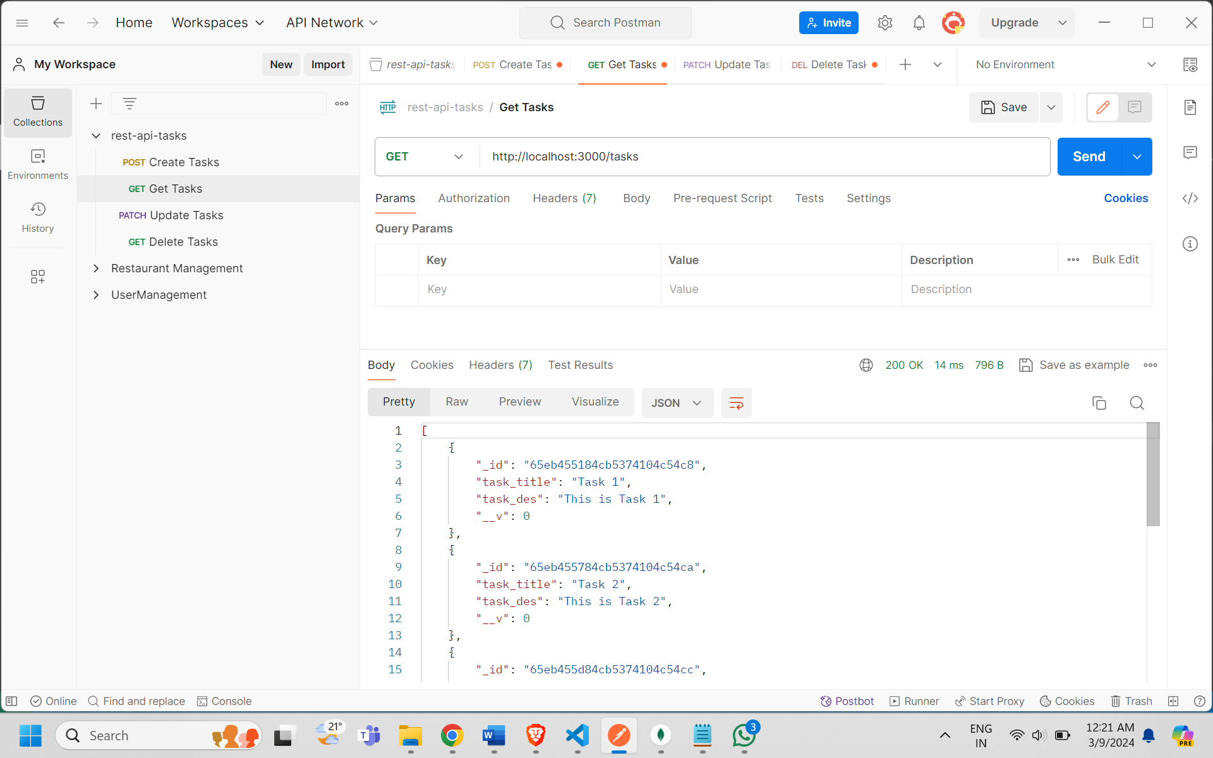

**Output from Mongodb**

